Chapter 5 – Page 230 - #8 5B MDoctor

# Problem Statement

Design a program that displays a table of the Celsius temperatures 0 through 20 and their Fahrenheit equivalents. The formula for converting a temperature from Celsius to Fahrenheit is:

F = 9/5C + 32

# Algorithm

1. Calculate Fahrenheit equivalent
2. Display Celsius and Fahrenheit equivalent
3. Repeat steps 1 and 2 until all conversions are complete

# IPO Chart

Main module

|  |  |  |
| --- | --- | --- |
| Input | Processing | Output |
| maxTemp | FOR counter < maxTemp   * SET fTemp = Calculate 9/5C + 32 | DISPLAY Celsius  DISPLAY Fahrenheit |

# Hierarchy Chart

No hierarchy chart due to only one module

# Flowchart

## Version 1.0

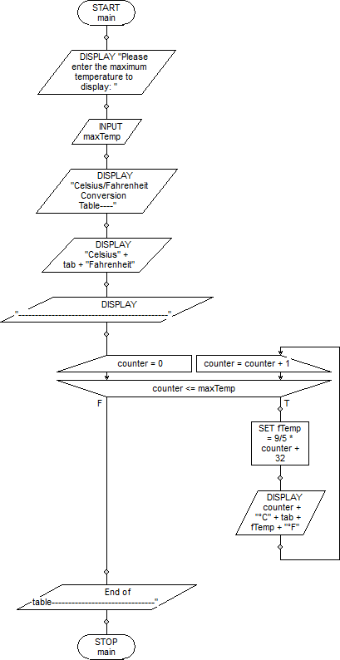

# Pseudocode

## Version 1.0

// Program: Chapter 5 - Page 230 - #8 5b MDoctor v1

// Author: Mark Doctor

// Course: iTech

void main ()

{

DISPLAY "Please enter the maximum temperature to display: ";

INPUT maxTemp;

DISPLAY "Celsius/Fahrenheit Conversion Table----";

DISPLAY "Celsius" + tab + "Fahrenheit";

DISPLAY "---------------------------------------------";

for (counter = 0; counter <= maxTemp; counter = counter + 1)

{

SET fTemp = 9/5 * counter + 32;

DISPLAY counter + "°C" + tab + fTemp + "°F";

}

End of table-------------------------------";

}

# Java Source Code

1 //Mark Doctor, 10/5/16, iTechPM Section 5: Assignment 5b  
 2 //Purpose: Learn FOR method  
 3 //Filename: temperatureTable.java  
 4 //Documentation: Chapter 5 - p230 - #8 MDoctor.docx  
 5   
 6 import java.util.*;  
 7   
 8 public class temperatureTable  
 9 {  
10 public static void main(String[] args)  
11 {  
12 //variable declaration  
13 Scanner kb = new Scanner(System.in);  
14 int maxTemp;   
15 double fTemp;  
16   
17 //get max temperature  
18 System.out.println("Please enter the maximum temperature: ");  
19 maxTemp = kb.nextInt();  
20   
21 //Table setup  
22 System.out.println("Celsius/Fahrenheit Conversion Table");  
23 System.out.println("-----------------------------------");  
24 System.out.println("Celsius\t\tFahrenheit");  
25 for(int counter = 0; counter <= maxTemp; counter++)  
26 {  
27 fTemp = (9 * (double)counter) /5 + 32;  
28 System.out.println(counter + "\t\t\t\t" + Math.round(fTemp));  
29 }  
30   
31 }//end of main  
32 }//end of class  
33 /*  
34 ▪Please enter the maximum temperature:   
35 ▪20  
36 ▪Celsius/Fahrenheit Conversion Table  
37 ▪-----------------------------------  
38 ▪Celsius Fahrenheit  
39 ▪0 32  
40 ▪1 34  
41 ▪2 36  
42 ▪3 37  
43 ▪4 39  
44 ▪5 41  
45 ▪6 43  
46 ▪7 45  
47 ▪8 46  
48 ▪9 48  
49 ▪10 50  
50 ▪11 52  
51 ▪12 54  
52 ▪13 55  
53 ▪14 57  
54 ▪15 59  
55 ▪16 61  
56 ▪17 63  
57 ▪18 64  
58 ▪19 66  
59 ▪20 68  
60 ▪  
61  ----jGRASP: operation complete.  
62   
63 */